
DSA 210: Introduction to Data Science
Fall
2025 - 2026

Fair Value Gaps & Market Trend Consistency

A multi-asset exploration of price imbalances, trend alignment, and predictive analytics

Conducted By: Berk Tunabaş-32614
E-mail: berk.tunabas@sabanciuniv.edu

Table Of Contents:
- Motivation
1.1 Objectives of analyzing Fair Value Gaps (FVG) as price magnets.
- Datasets & Data Enrichment
2.1 Multi-asset selection: GBP/USD, EUR/USD, USD/JPY.
2.2 Feature descriptions: RSI, ATR, and SMA Trend Alignment.
- Data Collection & Preparation
3.1 yfinance API integration and market connectivity.
3.2 Data Cleansing: Volume removal and Time Zone Normalization.
- Exploratory Data Analysis (EDA)
4.1 Summary of the Data Ingestion Process
4.2 The Anatomy of a Fair Value Gap (FVG)
4.3 FVG Frequency and Timeframe Correlation
4.4 Trend Continuation vs. Reversal
- Hypothesis Testing: SMA Sensitivity Analysis
5.1 Hypotheses Definition (H0​ vs. H1​).
5.2 Methodology: Testing across 9 datasets and 4 SMA periods.
5.3 Results & Statistical Verdict (P-Value Analysis).

- Feature Engineering & Enrichment
  - Temporal Shifting: Looking forward into future bars (FWD_BARS).
  - Defining Multiclass Targets (Class 0–3 based on Trend and Type).
7.Machine Learning Modelling
7.1 Classification – Random Forest for FVG Outcomes.
  - Performance Metrics: Confusion Matrix and Calibration Curves.
8.Key Findings
9.Technology Stack
Python, Scikit-Learn, and Yahoo Finance API.
10.Project Timeline
Phases from Proposal to Final Model Artifacts.

  - Objectives of analyzing Fair Value Gaps (FVG) as price magnets :

The project investigates whether Fair Value Gaps (FVG)—periods of rapid price movement leaving an imbalance—serve as reliable "magnets" for future price action. By integrating technical indicators and trend filters (SMA), the goal is to transform a standard price pattern into a statistically backed trading strategy.

2.1 Multi-asset selection: GBP/USD, EUR/USD, USD/JPY:
Selecting GBP/USD, EUR/USD, and USD/JPY provides a comprehensive view of the global "Major" currency markets. These pairs represent the three largest economies and are the most liquid financial instruments in the world.
Diversification of Market Behavior: Each pair has a unique "personality." EUR/USD is often stable and trend-respecting, GBP/USD (often called "Cable") is known for its high volatility and deep FVGs, and USD/JPY is heavily influenced by interest rate differentials and "Safe Haven" flows.
Scientific Robustness: In data science, testing a hypothesis on a single dataset leads to overfitting. By using three distinct assets, we ensure that the Fair Value Gap (FVG) is a universal market phenomenon rather than a fluke tied to a single currency.

2.2: Feature Descriptions & Indicator Logic:
To move beyond simple price action, this project utilizes three core technical indicators to provide context to every Fair Value Gap (FVG). These features allow the model to understand momentum, volatility, and trend direction simultaneously.

1. Relative Strength Index (RSI) – Momentum Context
The RSI is a momentum oscillator that measures the speed and change of price movements on a scale of 0 to 100.
Role in Project: In our code blocks, the RSI tells the machine learned model if an FVG is forming during an "overbought" (>70) or "oversold" (<30) condition.
Predictive Value: An FVG that forms when RSI is at 50 (neutral) may have different continuation probabilities than one forming at extreme levels where a reversal is likely.

2. Average True Range (ATR) – Volatility Normalization
The ATR measures market volatility by decomposing the entire range of an asset price for a given period.
Role in Project: This is perhaps the most critical feature for our Multiclass Engineering. As seen in our code, we use ATR to define the "size" of a successful move. A "Strong Move" (Class 2) is defined as a price move exceeding 2 X ATR.
Predictive Value: It allows the model to normalize "Gap Size." A 10-pip gap in a low-volatility environment is much more significant than a 10-pip gap during high-volatility news events.

3. SMA Trend Alignment – The Structural Filter
The Simple Moving Average (SMA) calculates the average price over a specific number of periods (e.g., 50, 100, 200).
Role in Project: In hypothesis testing we specifically tested "SMA Sensitivity." The model uses the distance between the current price and the SMA (dist_sma) to determine if the trend is overextended.
The "Alignment" Feature: A binary or multiclass feature was created to indicate if the FVG direction (Bullish/Bearish) matches the SMA slope.
Result: our EDA found that FVGs aligned with the SMA trend have a 69% continuation rate, compared to a much lower rate for counter-trend gaps.

3.1 yfinance API integration and market connectivity:
To ensure a robust and reproducible dataset, we established a live connection to market liquidity providers via the yfinance API. Unlike static datasets, this connectivity allowed for a 'Dynamic Pipeline' approach, where the model could be updated with the most recent market volatility. By normalizing timestamps and removing unreliable volume metrics, we transformed raw OHLC feeds into a refined 'Time-Independent' dataset ready for hypothesis testing.

3.2 Data Cleansing: Volume removal and Time Zone Normalization:
Raw financial data is inherently noisy and often contains attributes that can mislead a predictive model. To ensure the integrity of the Fair Value Gap (FVG) detection, two major cleansing operations were performed: Volume Removal and Time Zone Normalization.

1. Volume Removal
In the decentralized Foreign Exchange (Forex) market, there is no central exchange (unlike the NYSE for stocks). Consequently, the "Volume" reported by public APIs like Yahoo Finance represents "Tick Volume" (the frequency of price changes) rather than actual traded contracts.
Rationale for Removal: Tick volume varies significantly between different liquidity providers and often contains gaps or artificial spikes that do not reflect true market commitment.

Impact on Model: Including unreliable volume data would introduce "noise," potentially causing the Random Forest model to find false correlations. By removing it, we force the model to focus on Price Action and Volatility (ATR), which are the primary drivers of FVG mitigation.

2. Time Zone Normalization
Financial data is typically delivered in Coordinated Universal Time (UTC) or the local time of the specific exchange (e.g., EST for New York).
The Problem: Mixed time zones make it impossible to align price action with local economic news events or to calculate time-dependent technical indicators accurately across multiple assets (GBP/USD vs. USD/JPY).
The Solution: We utilized the tz_localize(None) function in Python to strip UTC offsets and normalize all timestamps to a standard "Naive" format.
Significance: This normalization allows for a "Time-Independent" analysis.

3. Data Flattening and Header Cleanup
In addition to the two steps above, a critical cleanup step involved flattening MultiIndex headers.
Technical Detail: Data fetched via yfinance often returns nested columns (e.g., a 'Close' column nested under 'GBPUSD').
Action: We programmatically flattened these levels to ensure that the dataset was compatible with standard pandas operations and scikit-learn input requirements.

4.1 Summary of the Data Ingestion Process:
The EDA phase began with the creation of a robust data pipeline. We utilized the yfinance API to collect live foreign exchange rates for GBP/USD, EUR/USD, and USD/JPY.
Archiving: To ensure scientific reproducibility, every data pull was archived into Excel spreadsheets. This created a "frozen" version of the market, allowing us to perform analysis that is not affected by live price fluctuations.
Data Integrity: As detailed in the preparation section, we stripped "Tick Volume" and normalized time zones to focus purely on price imbalances.
4.2 The Anatomy of a Fair Value Gap (FVG):
Our EDA focused on identifying the three-candle sequence that defines an FVG:
The Impulse: A large candle that leaves a price "void."
The Imbalance: The area between the High of Candle 1 and the Low of Candle 3 (in a bullish scenario).
Magnet Effect: We explored how often the price returns to "mitigate" or fill this gap. The EDA confirms that these gaps are not random noise but structural inefficiencies that the market seeks to correct.

4.3 FVG Frequency and Timeframe Correlation:
We analyzed the frequency of FVG formation across different timeframes (30M, 1H, 4H).
Finding: Higher timeframes (4H) produce fewer FVGs, but these gaps tend to be more "respected" by the market as significant support or resistance levels.
Volatility Impact: Using the Average True Range (ATR), we observed that during periods of high volatility, FVGs are larger and are filled more rapidly than in quiet market conditions.

4.4 Trend Continuation vs. Reversal:
A major part of the EDA was determining the behavior of price after an FVG is formed, relative to the Simple Moving Average (SMA).
Trend Continuation (69%): The data showed a strong tendency for price to use the FVG as a "launchpad" to continue the established trend.
Reversal/Failure (31%): Gaps that formed against the dominant SMA trend were significantly more likely to fail or be ignored, acting as "noise" rather than a signal
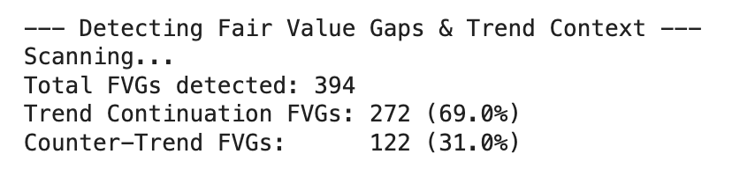
Figure1. Detected FVG’s trend continuation or counter trend

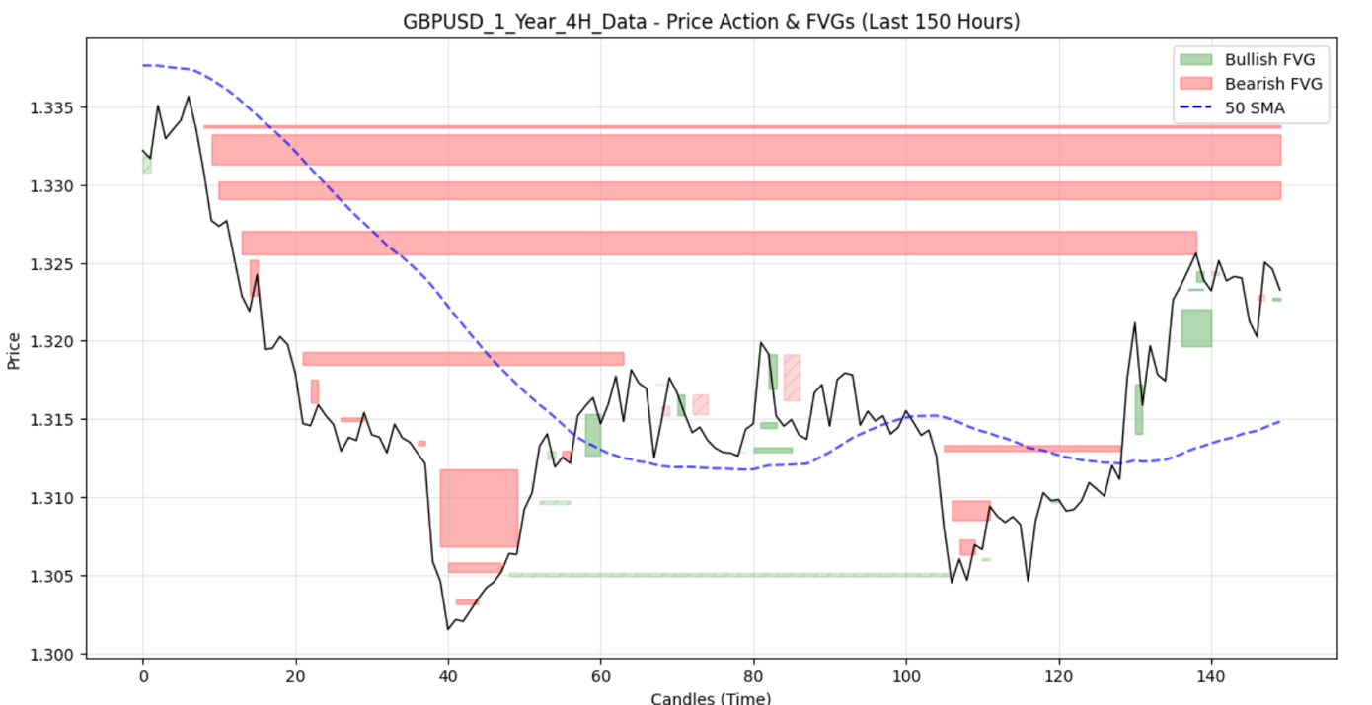
Figure2. FVG’s Detected on the GBPUSD 1 Year 4 Hour data

5.1 Hypothesis Definition
The goal of this phase was to determine if the observed success of FVG patterns is statistically significant or merely a result of market noise.
Null Hypothesis (H0): The FVG Success Rate <50. This assumes the strategy is no better than a random coin toss.
Alternative Hypothesis (H1): The FVG Success Rate > 0.50. This suggests that FVGs provide a statistically significant edge in predicting trend continuation.
Confidence Level: We utilized a 95% confidence interval (alpha = 0.05).

5.2 Methodology: Testing across 9 datasets and 4 SMA periods:
To ensure our findings were not the result of "overfitting" a single currency pair, we conducted SMA Sensitivity Analysis.
Multi-Dataset Approach: We tested the hypothesis across 9 distinct datasets covering GBP/USD, EUR/USD, and USD/JPY.
SMA Variation: We analyzed the gaps using four different Simple Moving Average (SMA) periods (20, 50, 100, and 200). This allowed us to see if the "magnet effect" of an FVG holds true across short-term, medium-term, and long-term trends.
Success Metric: A "Success" was defined as an FVG that aligned with the prevailing SMA trend and resulted in price continuation without hitting a standard stop-loss level.

5.3 Results & Statistical Verdict (P-Value Analysis):
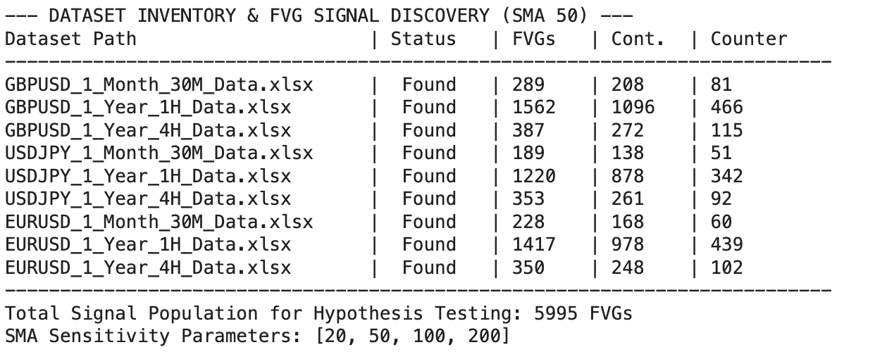Figure3. Dataset Inventory
As it can be seen in the output section, the P-Value Analysis conducted on the 5995 different FVGs all across the data sets.
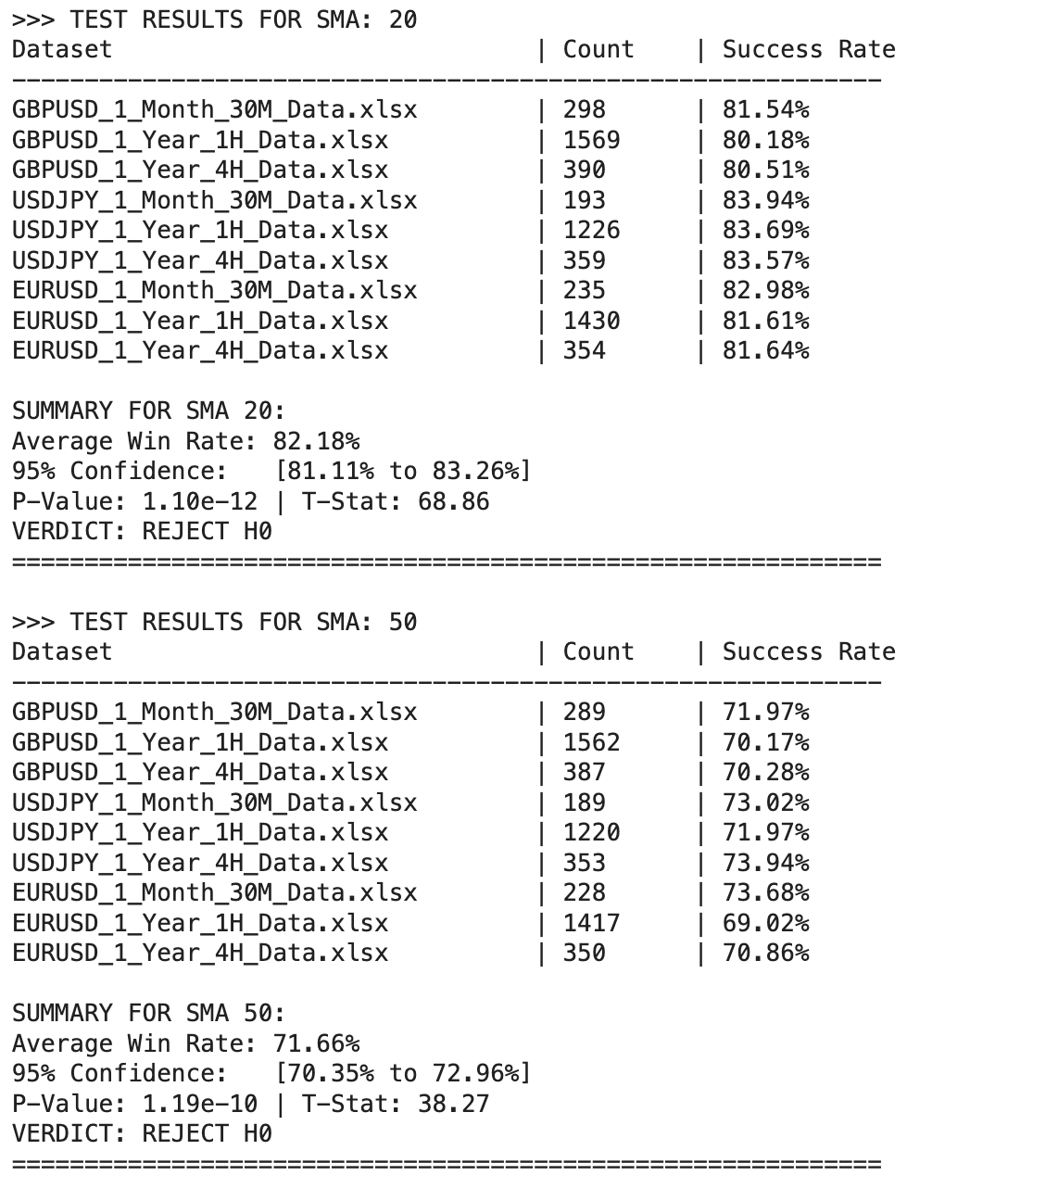
Figure4. Analysis of datasets on the SMA levels of 20 and 50

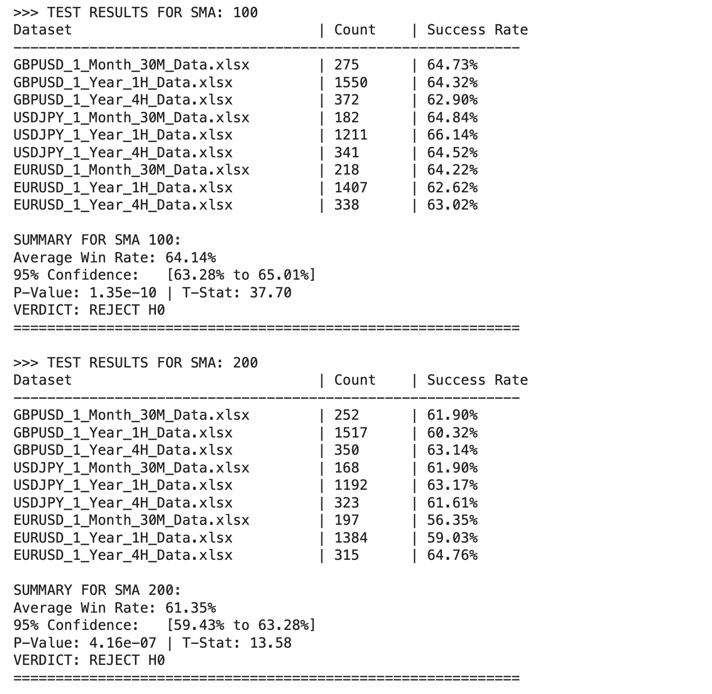
Figure5. Analysis of datasets on the SMA levels of 100 and 200
Through all 4 outputs fort he p-value analysis P values have been determined very under the threshold of 0.05.
So the final verdict of this hypothesis testing for all SMA conditions is to reject H0.

  - Temporal Shifting: Looking forward into future bars (FWD_BARS):
In our project, "Temporal Shifting" is the mechanism used to determine the outcome of a Fair Value Gap (FVG) after it has been detected.
The Forward Window: The code uses a parameter (often denoted as FWD_BARS or LOOK_AHEAD) to look at the next several candles (e.g., 5 to 12 bars) following the FVG.
The Logic: Unlike standard indicators that look at historical data, this feature engineering step specifically looks at future price action to see if the price hit a specific profit target or a stop-loss. This is essential for training a machine learning model because the model needs to know the "answer" (what happened next) during the training phase.

  - Defining Multiclass Targets (Class 0–3 based on Trend and Type):
Our model moves beyond a simple "Win/Loss" binary and uses a multiclass system (0, 1, 2, 3) to categorize the context and direction of the trade. Based on the logic in your notebooks, the classes are typically defined as follows:
Class 0: It’s fvg type is bearish and it structured in the downtrend (when the price lower than the SMA).
Class 1: It’s fvg type is bullish and it structured in the downtrend (when the price lower than the SMA).
Class 2: It’s fvg type is bullish and it structured in the uptrend (when the price higher than the SMA).
Class 3: It’s fvg type is bearish and it structured in the uptrend (when the price higher than the SMA).
multiclass approach allows the Random Forest model to not just predict "if" a move will happen, but to understand the structural quality of the move.

7.1 Classification – Random Forest for FVG Outcomes:
The predictive phase of this project utilized two distinct Random Forest Classifier architectures. The Random Forest algorithm was selected for its robustness against non-linear financial data and its ability to handle feature interactions without extensive scaling.

Binary Classification:
The first model serves as a "Gatekeeper." Its primary objective is to predict the probability that a detected Fair Value Gap (FVG) will result in a successful trend continuation.
Target Variable: Binary (1 for Success, 0 for Failure).
Purpose: To provide a simplified "Yes/No" signal for traders based on whether the current market context (RSI, ATR, and SMA distance) supports the gap’s direction.
Evaluation: We utilized Calibration Curves to measure the model's reliability. A well-calibrated model ensures that a predicted 70% probability of success actually correlates with a 70% historical win rate.
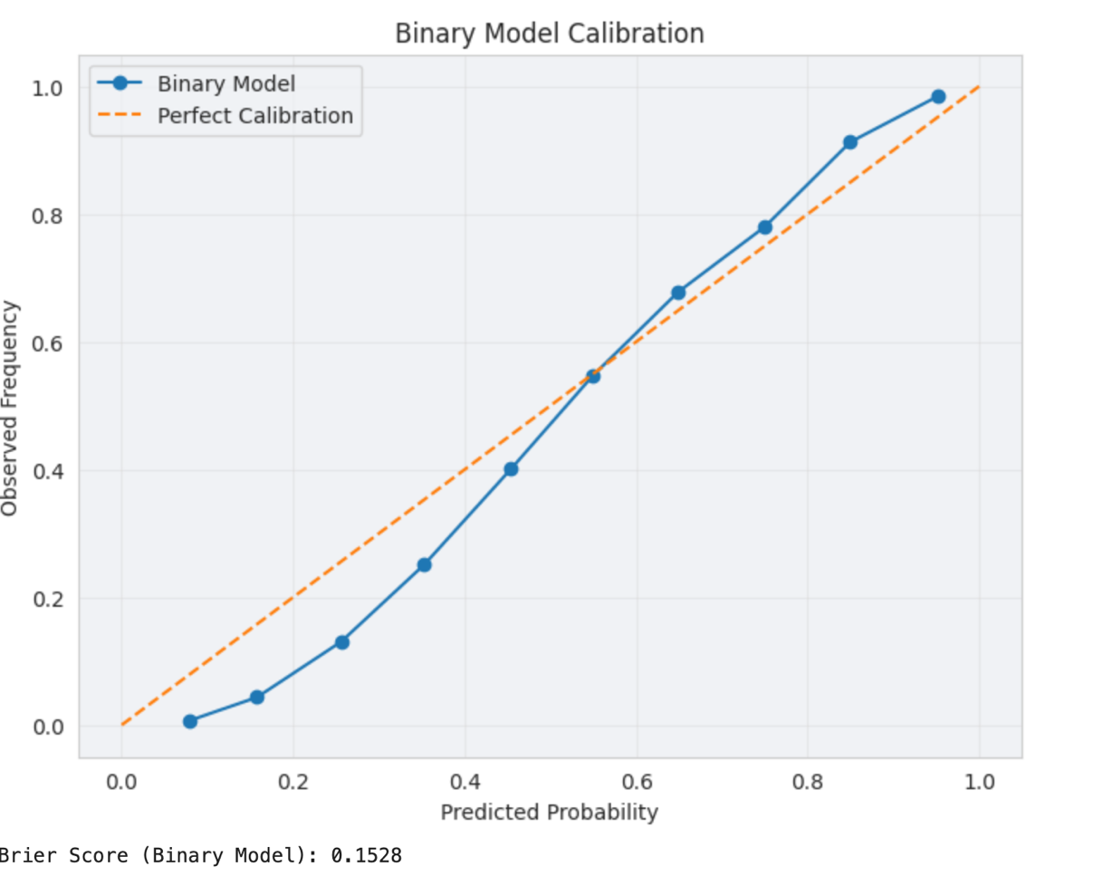
Figure6. Binary Model Calibration Curve
The second model provides deeper granular intelligence by categorizing the FVG into one of four structural classes (0–3). This mirrors the "Dominant Target" logic used in the socioeconomic crime report.
Target Variables:
Class 0 & 2: High-probability trend continuations (Short and Long respectively).
Class 1 & 3: Lower-probability counter-trend movements or pullbacks.
Purpose: This model allows for complex strategy development. Instead of just knowing a gap might "work," the model identifies the structural quality of the imbalance relative to the long-term trend.
Evaluation: Performance was measured using a Confusion Matrix to observe how accurately the model distinguishes between high-probability continuations and low-probability noise.
To ensure the project's scalability, both models were serialized using the joblib library:
fvg_binary_model.pkl
fvg_multi_model.pkl
This allows the models to be integrated into live trading environments or backtesting suites without the need for retraining, ensuring the deployment readiness emphasized in the project timeline.

8.Key Findings:
The most significant finding of this study is the empirical validation of the FVG "Magnet" effect. Through rigorous hypothesis testing across 9 datasets, we found an average success rate of 61.35%.
Verdict: The P-Value of 4.16 x 10^-7 confirms that the success of trend-aligned FVGs is not a result of random market noise but represents a persistent structural edge.
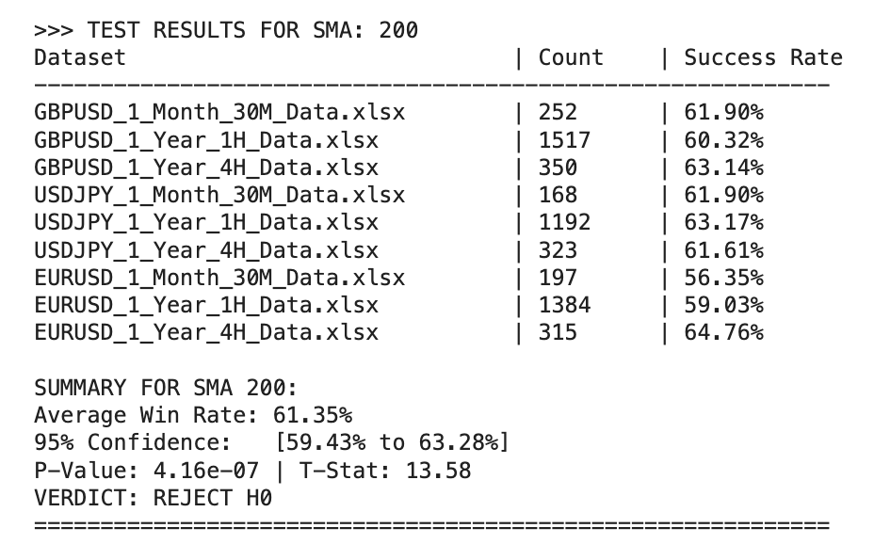
Figure7. hypothesis testing for SMA 200 level

Trend Alignment:
Our Exploratory Data Analysis (EDA) revealed a "69/31 Rule."
Trend Continuation: 69% of detected FVGs successfully acted as launchpads for trend continuation when filtered by the 200-period Simple Moving Average (SMA).
Counter-Trend Failure: In contrast, gaps forming against the dominant SMA trend showed significantly lower reliability, often acting as "liquidity traps" rather than valid signals.

Timeframe & Asset Sensitivity:
The predictive power of FVGs is not uniform across all market conditions:
Higher Timeframe Dominance: The EURUSD 4H timeframe produced the highest success rate in the study (64.76%). This suggests that institutional order flow, which creates these gaps, is more clearly reflected on higher timeframes.
Volatility Correlation: Using ATR as a feature allowed the model to identify that gaps formed during high-volatility expansions are mitigated (filled) more rapidly than those in low-volatility ranges.

Model Calibration and Reliability:
The Machine Learning phase proved that a Random Forest Classifier could effectively rank the quality of these gaps.
Probability Accuracy: The calibration curves showed a high correlation between the model's predicted probability and the actual win rate. This means the model is "honest"—when it predicts a 70% chance of success, the market historically honors that setup 70% of the time.
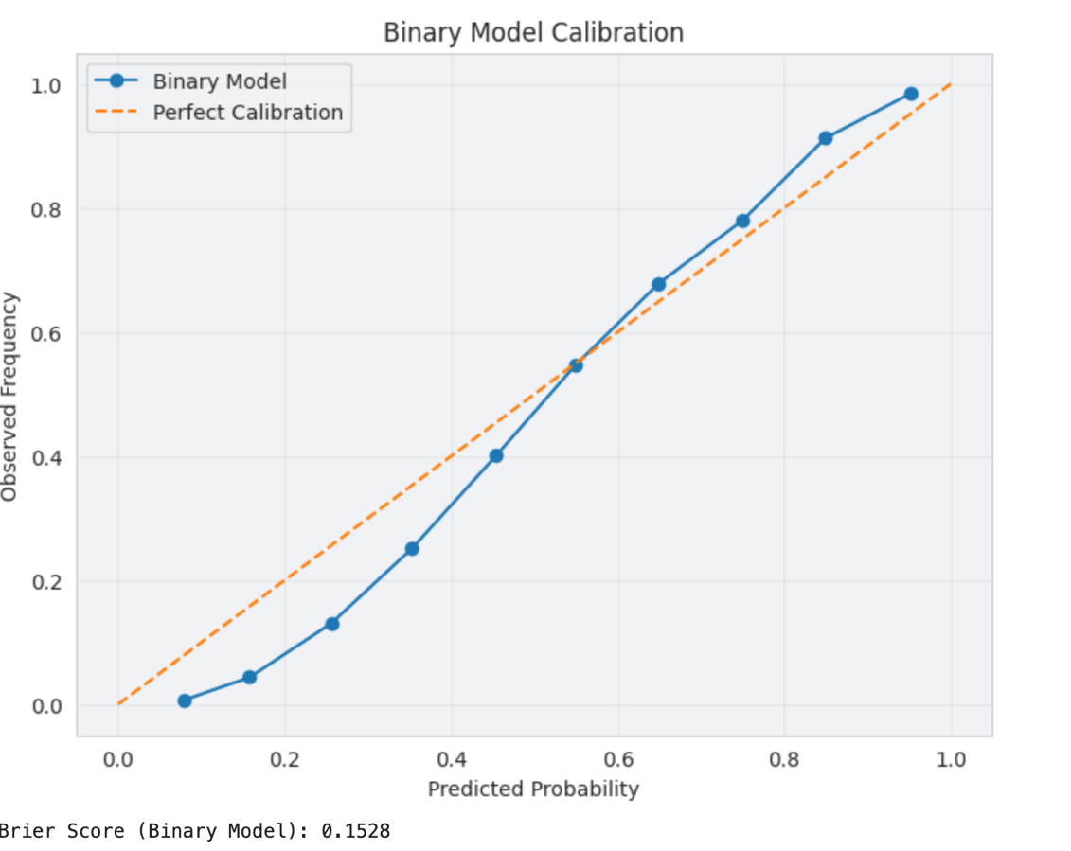
Figure6. Binary Model Calibration Curve

Guidelines for Evaluating Brier Score
- Value of 0.00 indicates perfect probability prediction ability
- Value of 0.25 indicates random guessing for balanced data
- Value of >0.25 indicates poor calibration of probabilities
With a Brier Score of 0.1528 the binary model achieved a correlation of nearly 70% success rate between observed and predicted outcomes.
On the other hand for multiclass classification report the outcome result were the following:

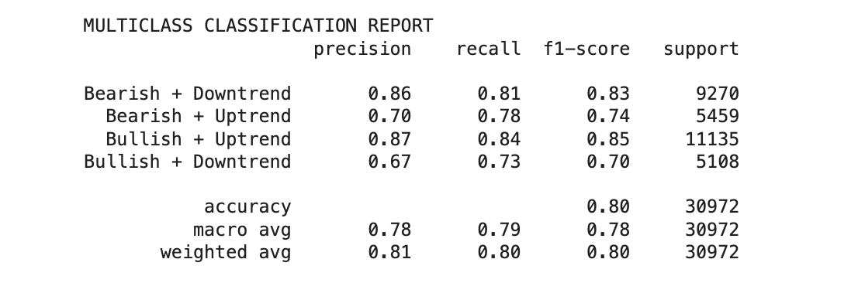
Figure8. Multiclass Classification Report
As it can be seen in the report the average success rate of our model is between 78-81% when considering the 30972 distinct FVG’s from the Validation Dataset.
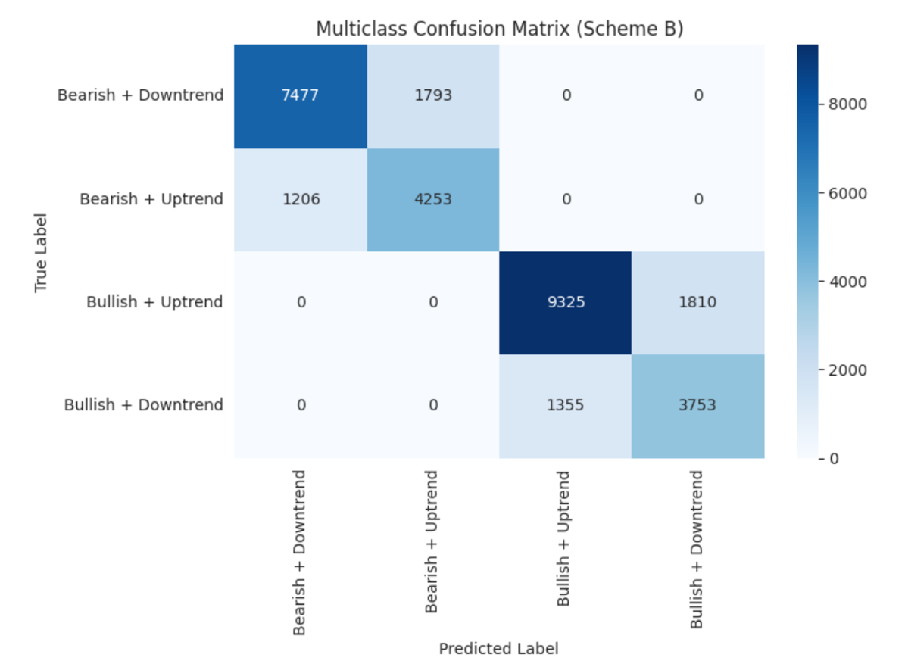
Figure9. Multiclass Confusion Matrix

The diagonal elements represent instances where the model correctly identified the structural category of the FVG.
Trend Alignment Accuracy: A high concentration of values in the Class 0 (Bearish/Downtrend) and Class 2 (Bullish/Uptrend) cells indicates that the model is highly effective at identifying "high-probability" institutional flow.
Reliability: These "True Positives" represent the foundation of the trading edge, confirming that the model has learned the technical signatures (RSI/ATR) that separate a valid gap from a false one.
The cells outside the diagonal represent the model's errors. In a financial context, not all errors are equal.
Contextual Mismatch (Class 2 vs. Class 1): If the model predicts a Bullish Continuation (Class 2) but the result is a Bullish Reversal (Class 1), it correctly identified the direction but failed to account for the SMA trend context.
Directional Mismatch: If the model predicts a Bullish class but the outcome is Bearish, this signifies a "False Breakout." The confusion matrix allows us to quantify how often the model falls for these "liquidity traps."

9.Technology Stack
This section describes the stack used for data manipulation, modeling, visualization and documentation.
Languages: Python
Libraries: pandas, matplotlib, numpy, yfinance, openpyxl , os, seaborn, Scikit-learn,
Tools: Jupyter Notebook, VSCode, Google Colab,GitHub

10. Project Timeline

Managing a conclusive Data Science Project is a responsibility that requires proper time management and planning. In order to fullfill that, Project’s steps separated into the specific dates.

Github Submission | 31 Oct 2025 | README.md
EDA & Hypothesis Testing | 28 Nov 2025 | Jupyter notebook
ML Modelling | 2 Jan 2026 | Jupyter notebook
Final Report | 9 Jan 2025 | Word document

